# Exploration and Fidelity by the players

Exploration based on the lagged paths of the players (path lagging behind the current path by one play)

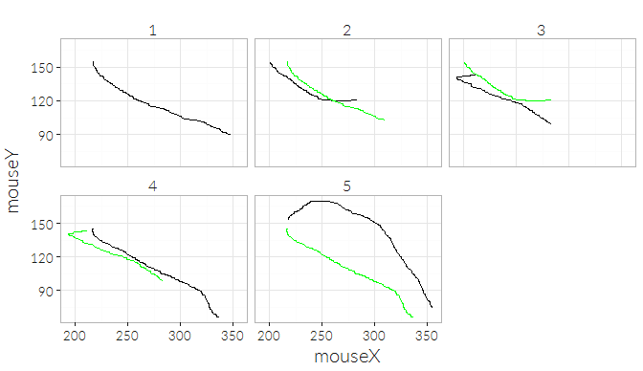

Result: linear relationship between the variation across plays in the x-direction and in the y-direction

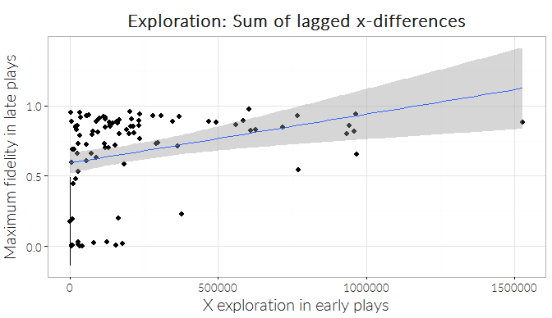cor = .30

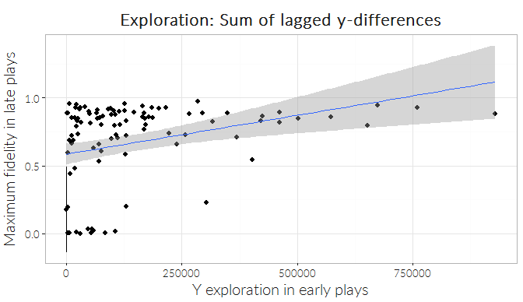cor = .31